**10 SCIENCE 2015 Mr Lafferty**

### CHEMISTRY TEST ONE

Name: ___________________________________ Mark: /

**SECTION A: MULTIPLE CHOICE (45 marks)**

**Please answer on the multiple choice answer grid below.**

**Please note there is a periodic table on the back page to help answer the questions.**

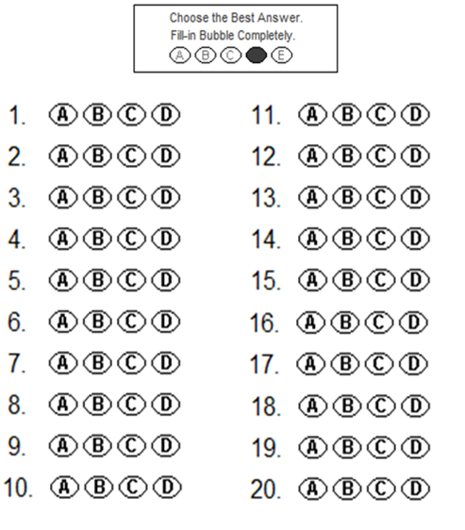



**1.** If a copper atom loses electrons it will become a:

1. Positive ion.
2. Negative ion.
3. Neutral ion.
4. Gas.

**2.** Which of the following contains only elements?

1. Ag, CO2, Cu.
2. Cu, Fe2O3, NaCl.
3. Ag, Pb, CH4.
4. Cu, Ni, Mg.

**3.** Choose the correct definition for an ion.

(a) The area of an atom where electrons are found.

(b) The smallest part of a cell.

(c) A charged particle.

(d) The smallest part of an element that is unable to take place in a chemical reaction.

**4.** Which of the following lists contains only metals?

1. Na, O, N, Ag.
2. Ag, Ne, Fe, Pb.
3. Ag, Au, Fe, Ca
4. O, N, C, Ag.

**5.** Which of the following is **NOT TRUE?**

1. Helium is a noble gas so it is very stable and unreactive.
2. The symbol Pb represents a metal.
3. Gold is brittle.
4. Mercury is the only metal to be a liquid at room temperature.

**6.** Gold is:

(a) able to conduct electricity and is brittle.

(b) able to conduct electricity and is malleable.

(c) not able to conduct electricity and is brittle.

(d) not able to conduct electricity and is malleable.

**7.** The noble gases are all:

(a) found on the right hand side of the periodic table and highly reactive.

(b) found on the left hand side of the periodic table and highly reactive.

(c) found on the right hand of the periodic table and unreactive.

(d) found on the left hand of the periodic table and unreactive.

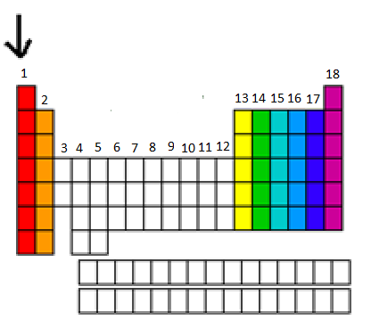**8.** The arrow is pointing to a:

(a) genre.

(b) period.

(c) group.

(d) bar.

**9.** Which of the following are all transition metals?

(a) Li, Mn, Ca.

(b) Au, Fe, Cu.

(c) F, Cl, Br.

(d) Na, K, Fe.

**10.** Group 18 elements are called the:

1. Alkali metals.
2. Metalloids.
3. Halogens.
4. Nobel gasses.

**SECTION B: SHORT ANSWER**

**Go to next page.**

|  |  |
| --- | --- |
| **Element** | **Symbol** |
| Helium |  |
|  | Be |
| Carbon |  |
|  | P |
|  | K |
| Calcium |  |
|  | Li |
|  | B |
| Silicon |  |
|  | S |
|  | Cl |
| Oxygen |  |
|  | H |
| Nitrogen |  |
|  | F |
| Neon |  |
| Aluminium |  |
|  | Ar |
| Sodium |  |
|  | Mg |

Section B. 1. Fill in this table

(10 marks)

**2a.** Onto this Periodic table write the following into the correct group columns: Halogens, noble gasses, alkali metals, Alkaline Earth metals, and transition metals.

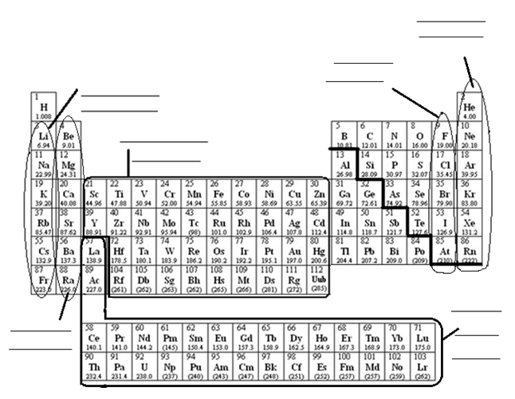

(5 marks)

**b.** Fill in the table below using the periodic table from the previous page. (5 marks)

|  |  |
| --- | --- |
| Element | Name of the group of the periodic table |
| Lithium |  |
| Helium |  |
| Chlorine |  |
| Iron |  |
| Argon |  |

**3.** Label the diagram of the atom below. (4 marks)

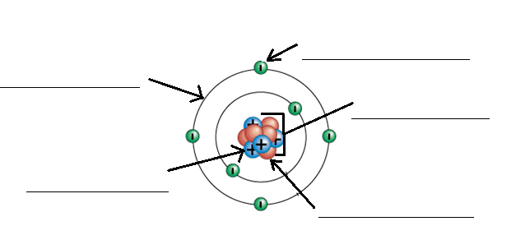

**4.**

Use arrows to connect the correct word to the correct meaning.

|  |  |  |
| --- | --- | --- |
| Word | Arrows | Meaning |
| Element |  | Where two or more different elements are chemically combined. |
| Compound | Able to be stretched into wires. |
| Malleable | Able to be hammered into sheets or different shapes. |
| Ductile | A charged particle |
| Ion | Will shatter when hit with a hammer. |
| Brittle | A pure substance made up of only one type of atom |

(6 marks)

**5.** Complete this table. The first example has been done for you.

|  |  |  |
| --- | --- | --- |
| Name of compound | Formula | Number and type of element present. |
| Carbon dioxide | CO2 | 1 carbon  2 oxygen |
| Iron sulphate | FeSO4 |  |
| Sulphuric acid | |  |  | | --- | --- | |  | H2SO4 | |  |
| Zinc Chloride | ZnCl2 |  |
| Butane | C4H10 |  |
| Chromium oxide | Cr2O3 |  |

(5 marks)

